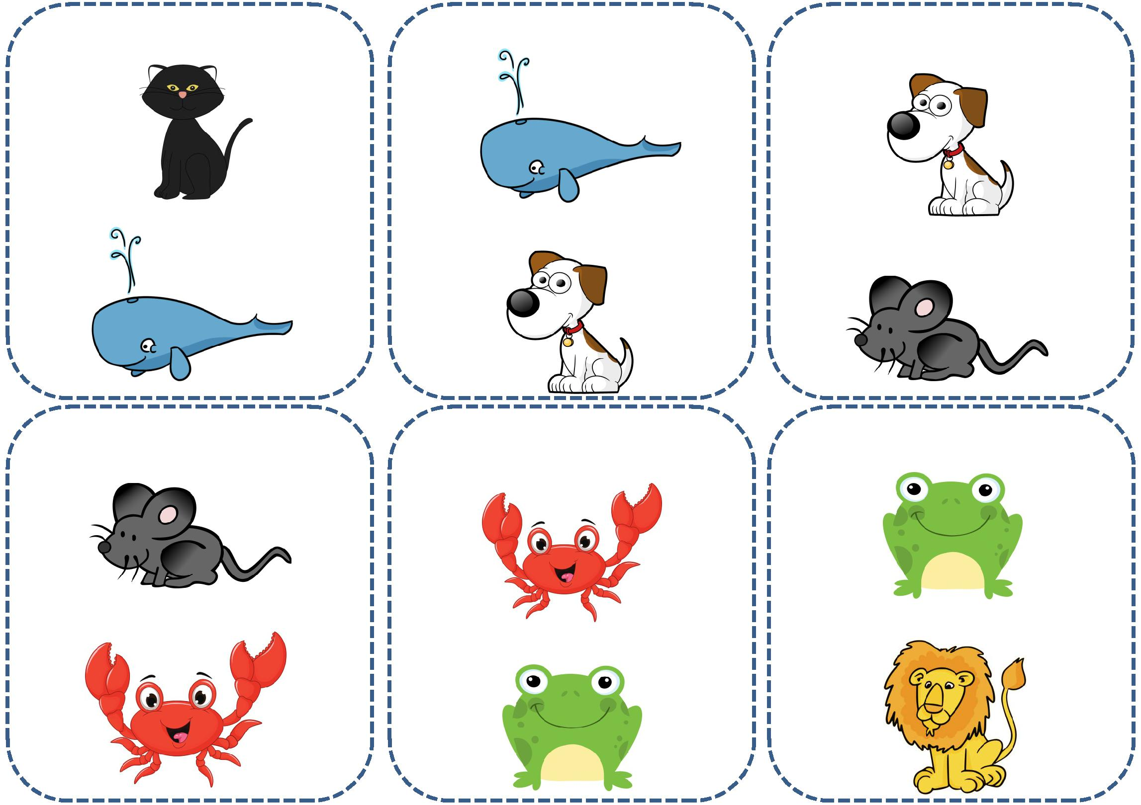I’VE GOT A CAT. I’VE GOT A WHALE. I’VE GOT A DOG.

|  |  |  |  |
| --- | --- | --- | --- |
| WHO’S GOT A WHALE? | WHO’S GOT A DOG? | WHO’S GOT A MOUSE ? |  |
|  |  |  |

I’VE GOT A MOUSE. I’VE GOT A CRAB. I’VE GOT A FROG.

|  |  |
| --- | --- |
| WHO’S GOT A CRAB? | WHO’S GOT A LION? |
|  | WHO’S GOT A FROG? |

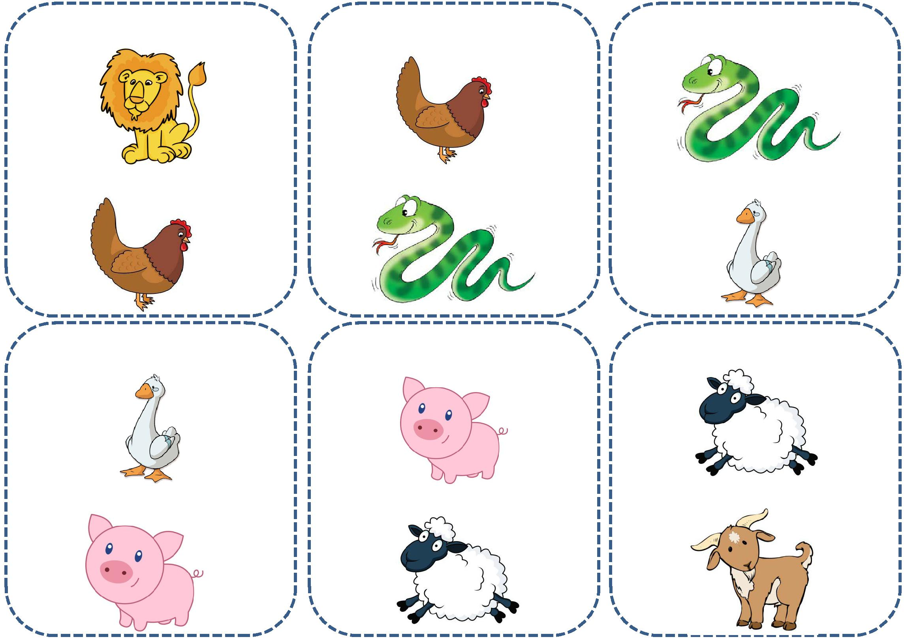I’VE GOT A LION. I’VE GOT A HEN. I’VE GOT A SNAKE.

WHO’S GOT A HEN? WHO’S GOT A SNAKE? WHO’S GOT A GOOSE?

I’VE GOT A GOOSE. I’VE GOT A PIG. I’VE GOT A SHEEP.

WHO’S GOT A PIG? WHO’S GOT A SHEEP? WHO’S GOT A GOAT?

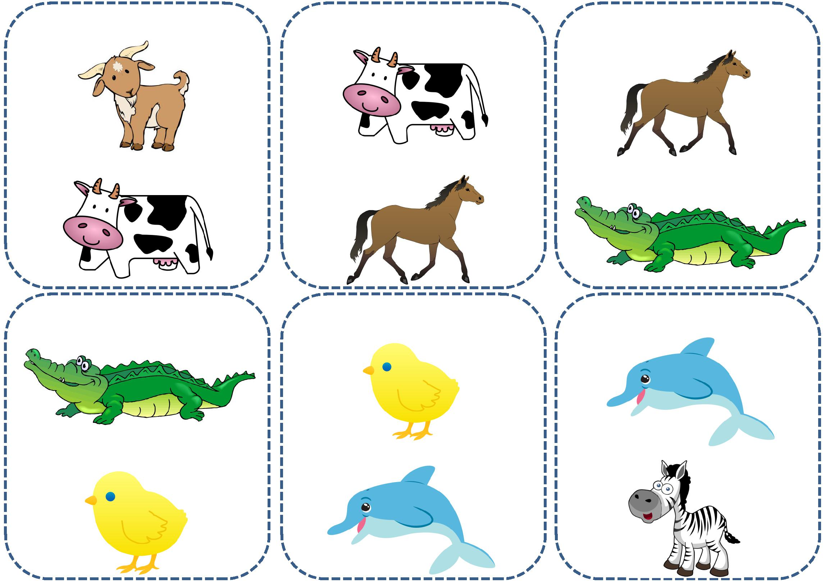I’VE GOT A GOAT. I’VE GOT A COW. I’VE GOT A HORSE.

|  |  |  |  |  |
| --- | --- | --- | --- | --- |
| WHO’S GOT A COW? | WHO’S GOT A HORSE? | WHO’S GOT A | CROCODILE |  |
|  |  | ? |  |

I’VE GOT A CROCODILE. I’VE GOT A CHICK. I’VE GOT A DOLPHIN.

WHO’S GOT A CHICK? WHO’S GOT A DOLPHIN? WHO’S GOT A ZEBRA?

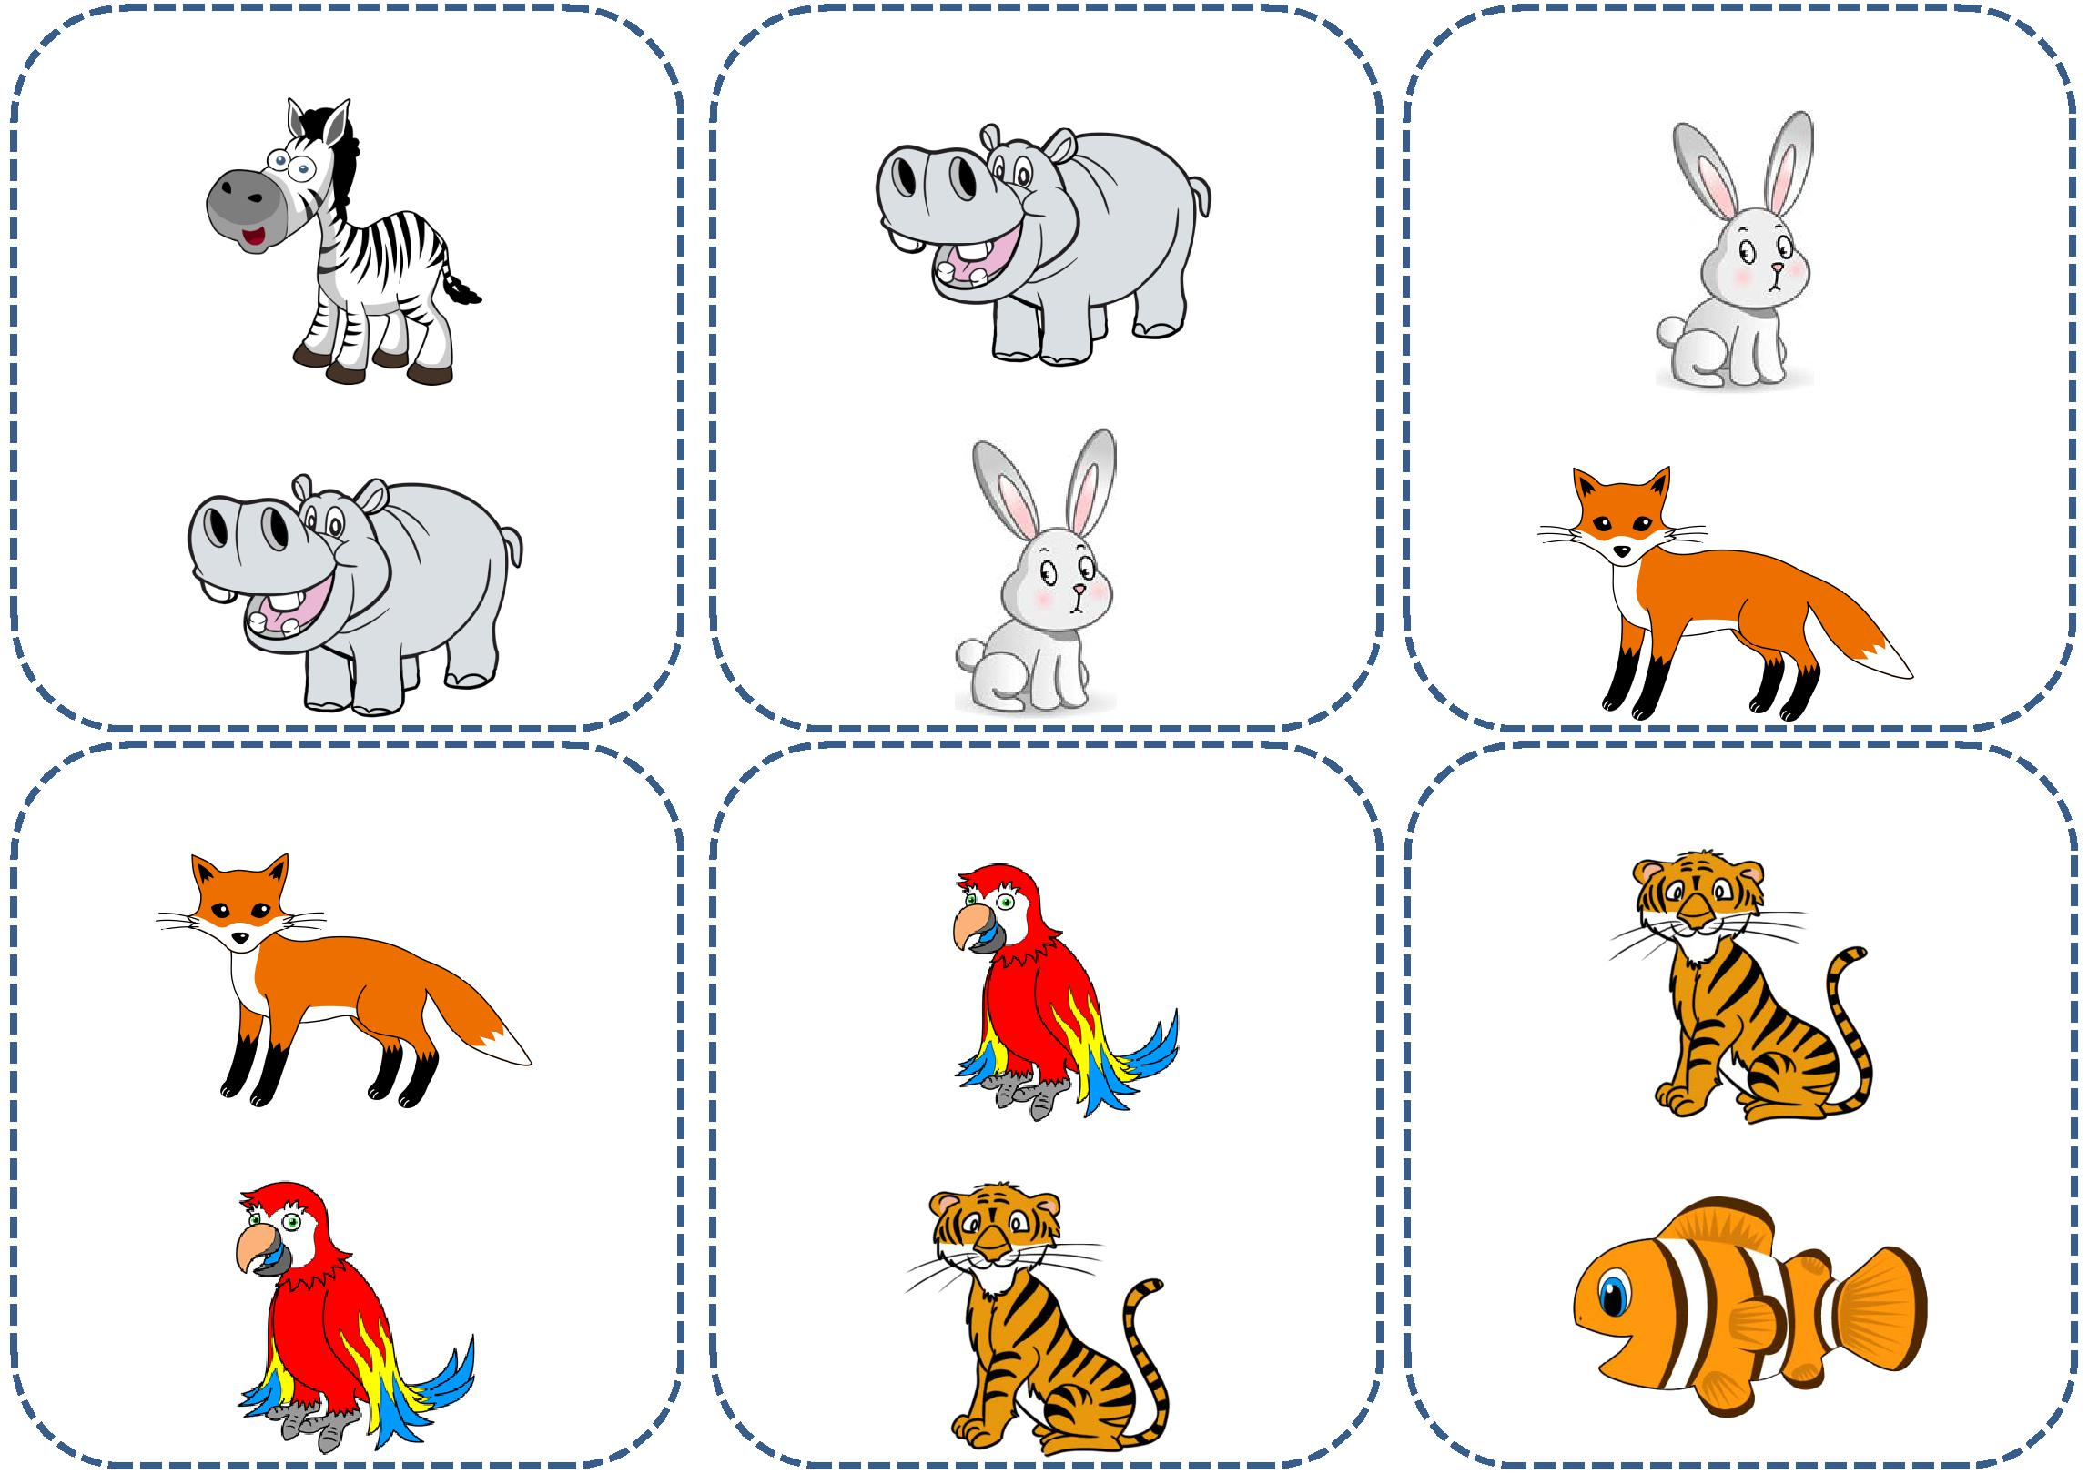I’VE GOT A ZEBRA. I’VE GOT A HIPPO. I’VE GOT A RABBIT .

WHO’S GOT A HIPPO? WHO’S GOT A RABBIT? WHO’S GOT A FOX?

I’VE GOT A FOX. I’VE GOT A PARROT. I’VE GOT A TIGER.

WHO’S GOT A PARROT? WHO’S GOT A TIGER? WHO’S GOT A FISH?

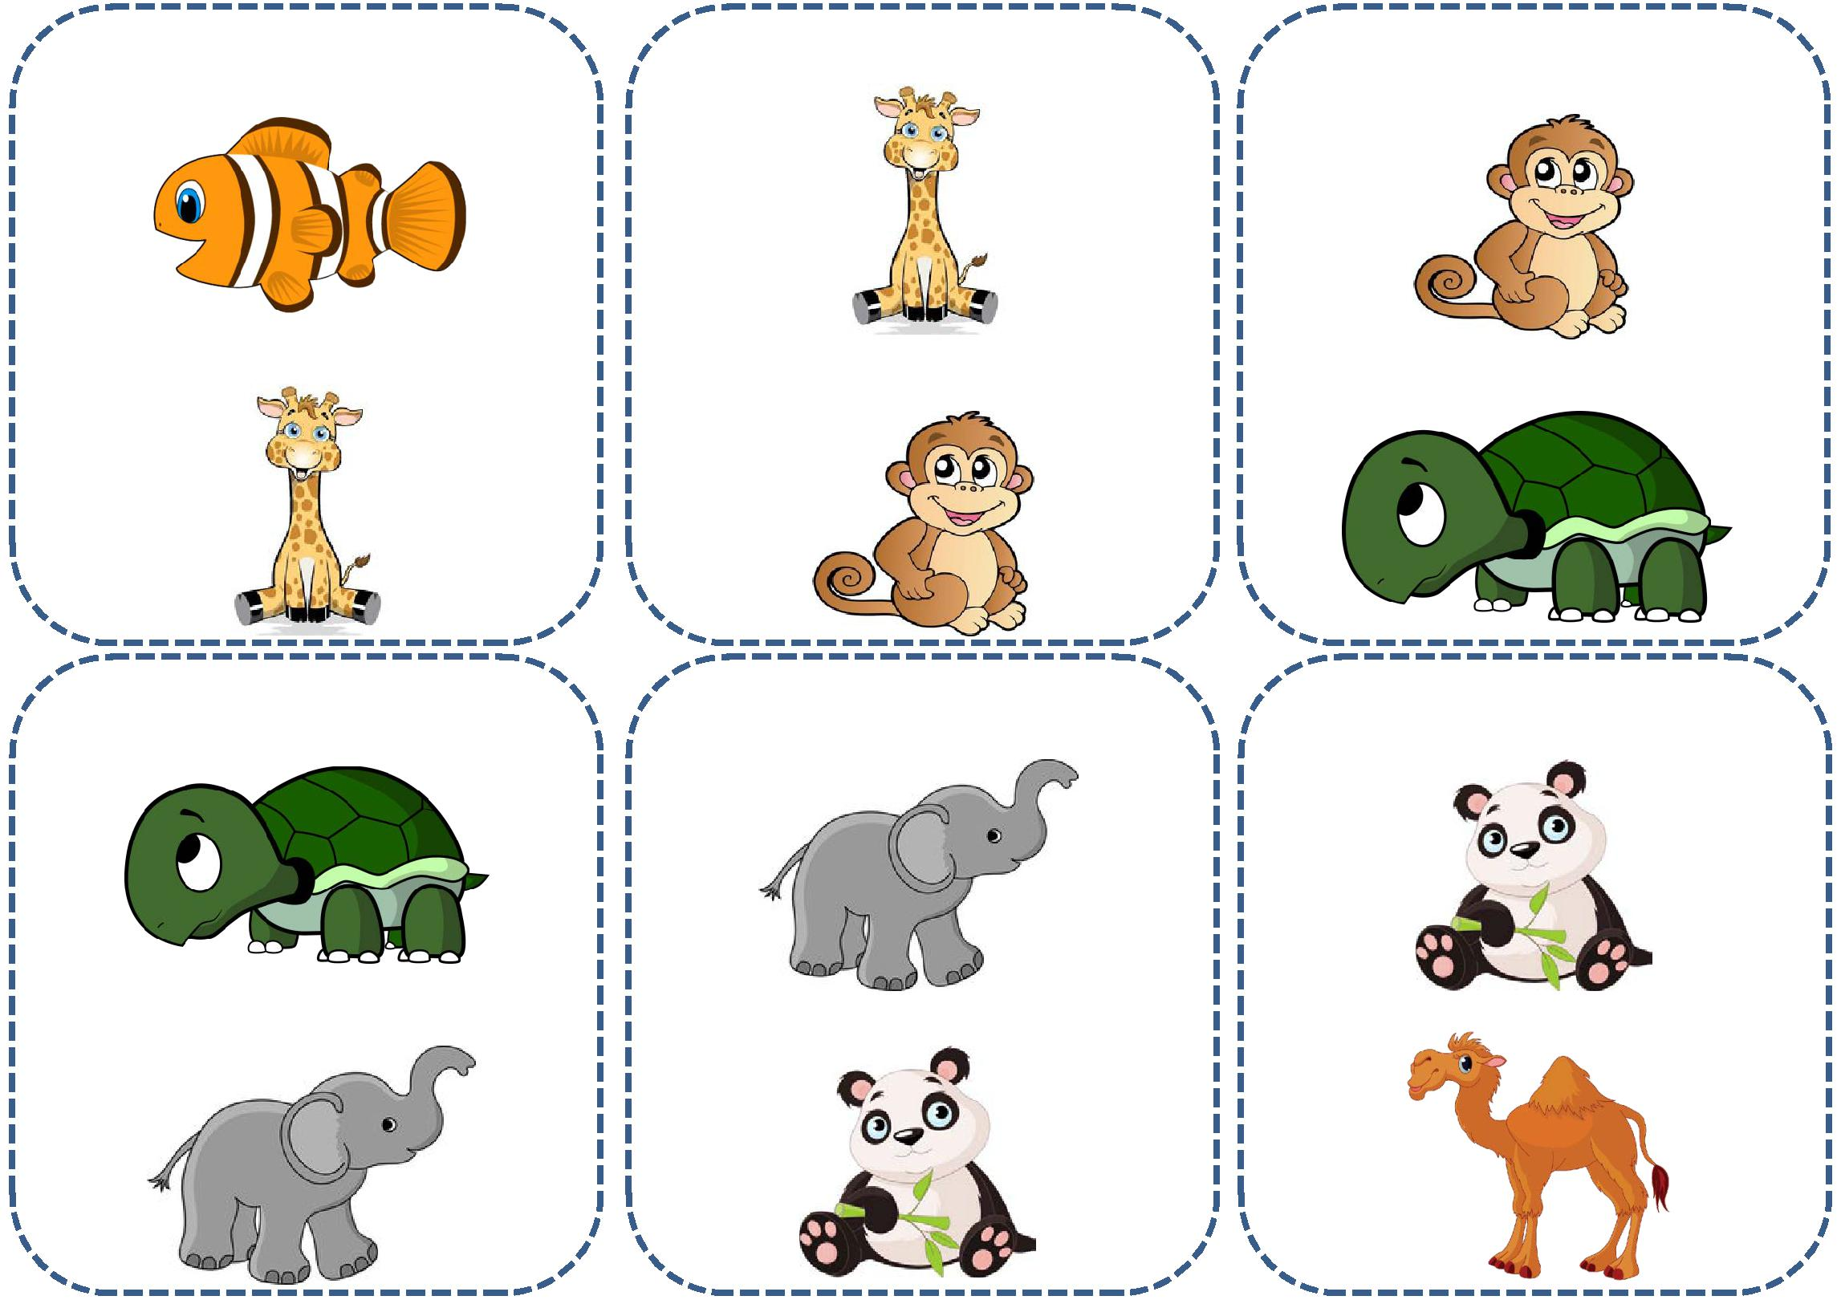I’VE GOT A FISH. I’VE GOT A GIRAFFE. I’VE GOT A MONKEY.

WHO’S GOT A GIRAFFE? WHO’S GOT A MONKEY? WHO’S GOT A TURTLE?

I’VE GOT A TURTLE. I’VE GOT AN ELEPHANT. I’VE GOT A PANDA.

WHO’S GOT AN ELEPHANT? WHO’S GOT A PANDA? WHO’S GOT A CAMEL?

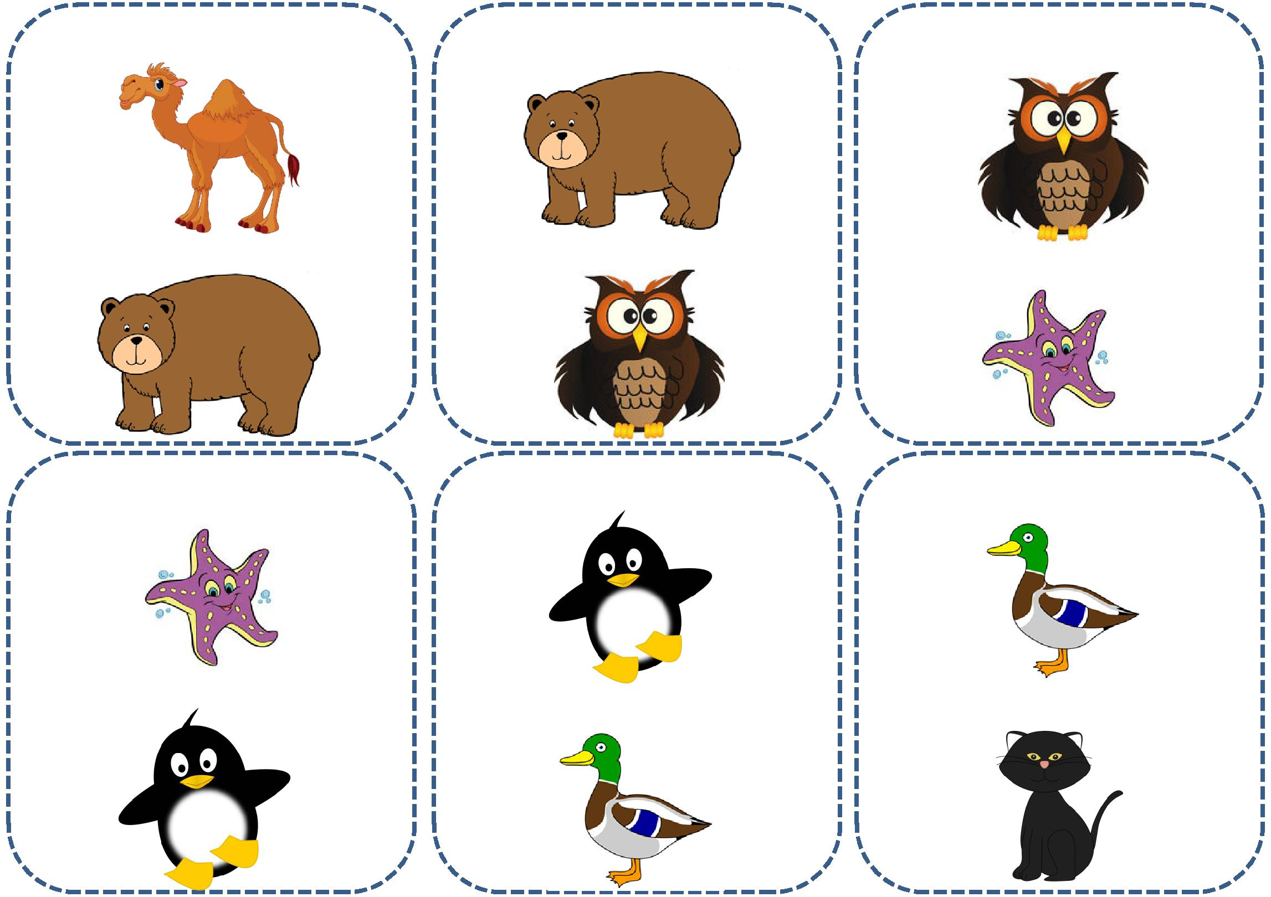I’VE GOT A CAMEL. I’VE GOT A BEAR. I’VE GOT A OWL.

WHO’S GOT A BEAR? WHO’S GOT A OWL? WHO’S GOT A STARFISH?

I’VE GOT A STARFISH. I’VE GOT A PENGUIN. I’VE GOT A DUCK.

WHO’S GOT A PENGUIN? WHO’S GOT A DUCK? WHO’S GOT A CAT?