

**_ _ _ _ _ _ _ _ _ _ _ _ _ _ _ _ _ _ _ _ _** **_ _ _ _ _ _ _ _ _ _ _ _ _ _ _ _ _ _ _ _ _** **_**

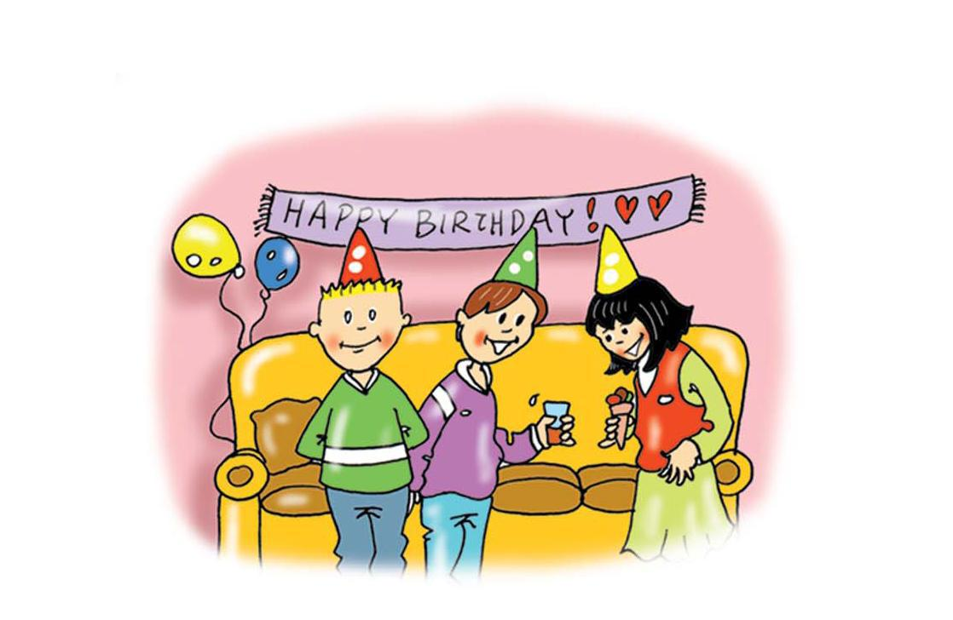

**candles**

**party**



**_ _ _ _ _ _ _ _ _ _ _ _ _ _ _ _ _ _ _ _ _** **_ _ _ _ _ _ _ _ _ _ _ _ _ _ _ _ _ _ _ _ _** **_**



**happy**

**sad**



**_ _ _ _ _ _ _ _ _ _ _ _ _ _ _ _ _ _ _ _ _** **_ _ _ _ _ _ _ _ _ _ _ _ _ _ _ _ _ _ _ _ _** **_**



**one**

**two**



**_ _ _ _ _ _ _ _ _ _ _ _ _ _ _ _ _ _ _ _ _** **_ _ _ _ _ _ _ _ _ _ _ _ _ _ _ _ _ _ _ _ _** **_**



**three**

**four**



**_ _ _ _ _ _ _ _ _ _ _ _ _ _ _ _ _ _ _ _ _** **_ _ _ _ _ _ _ _ _ _ _ _ _ _ _ _ _ _ _ _ _** **_**



**five**

**six**



**_ _ _ _ _ _ _ _ _ _ _ _ _ _ _ _ _ _ _ _ _** **_ _ _ _ _ _ _ _ _ _ _ _ _ _ _ _ _ _ _ _ _** **_**



**seven**

**eight**



**_ _ _ _ _ _ _ _ _ _ _ _ _ _ _ _ _ _ _ _ _** **_ _ _ _ _ _ _ _ _ _ _ _ _ _ _ _ _ _ _ _ _** **_**



**nine**

**ten**



