

**_ _ _ _ _ _ _ _ _ _ _ _ _ _ _ _ _ _ _ _** **_ _ _ _ _ _ _ _ _ _ _ _ _ _ _ _ _ _ _ _ _ _**

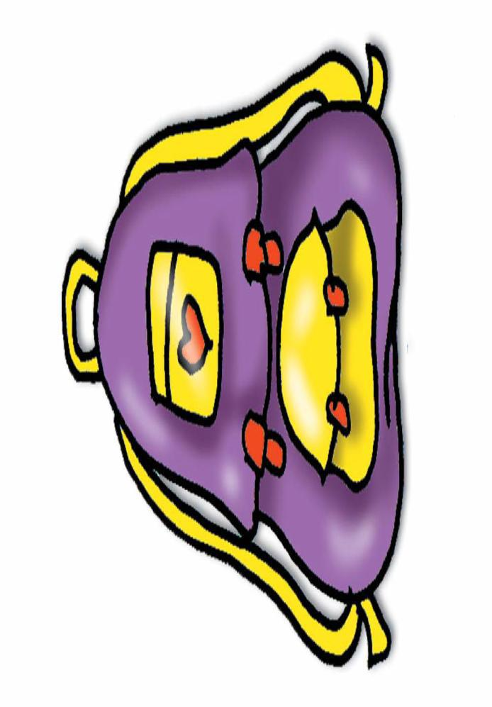

**school**

**school bag**

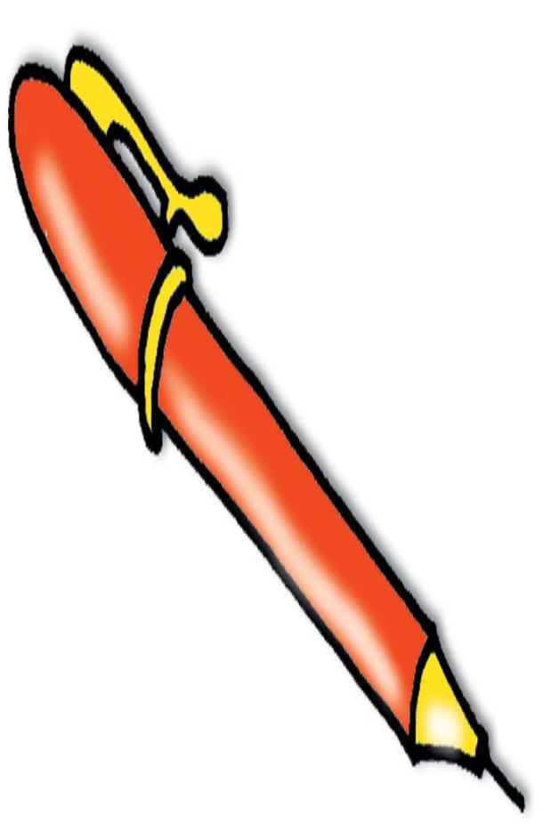

**_ _ _ _ _ _ _ _ _ _ _ _ _ _ _ _ _ _ _ _** **_ _ _ _ _ _ _ _ _ _ _ _ _ _ _ _ _ _ _ _ _ _**

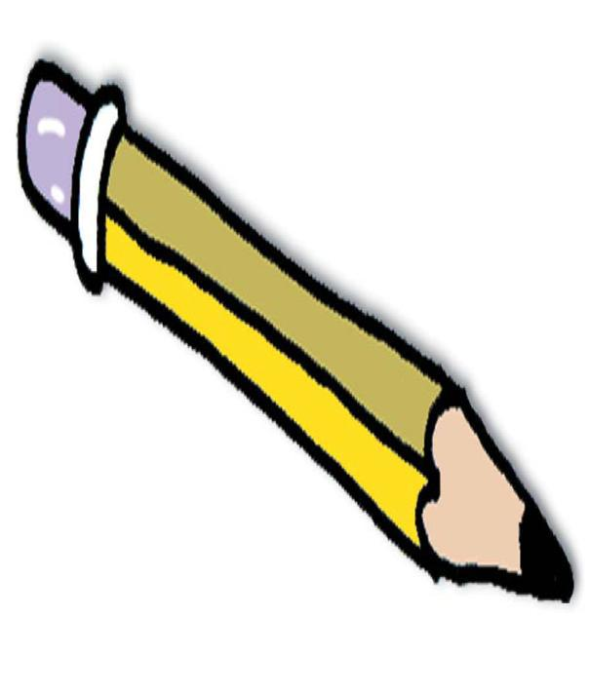

**pen**

**pencil**

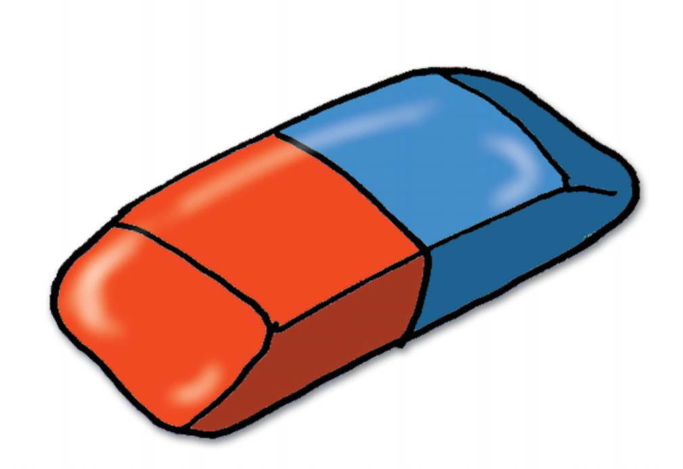

**_ _ _ _ _ _ _ _ _ _ _ _ _ _ _ _ _ _ _ _ _** **_ _ _ _ _ _ _ _ _ _ _ _ _ _ _ _ _ _ _ _ _** **_**

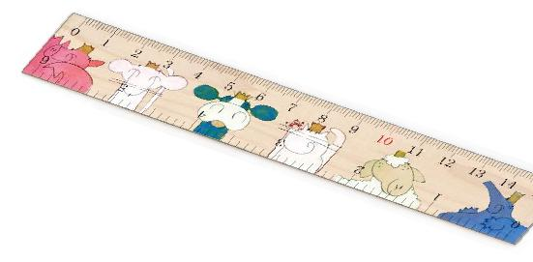

**rubber**

**ruler**

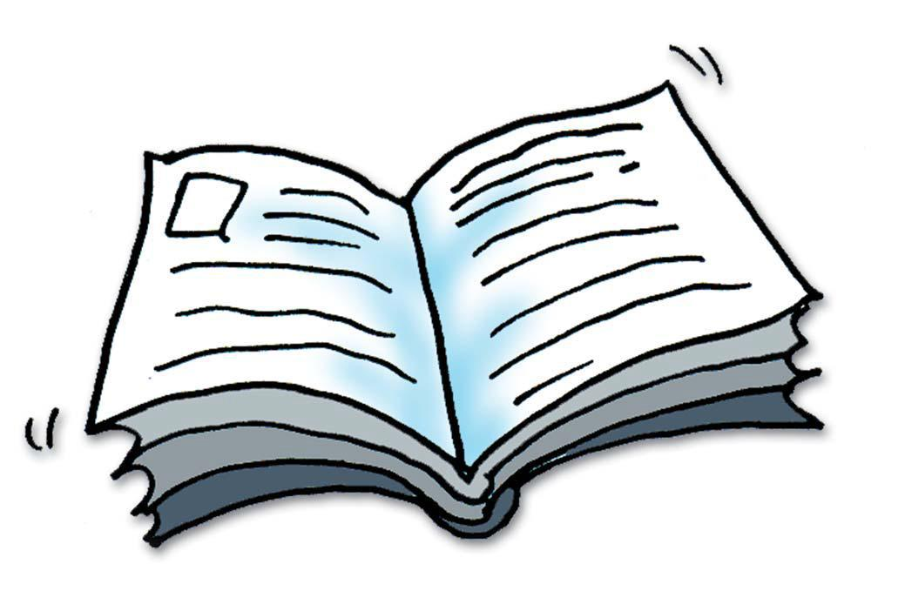

**_ _ _ _ _ _ _ _ _ _ _ _ _ _ _ _ _ _ _ _ _** **_ _ _ _ _ _ _ _ _ _ _ _ _ _ _ _ _ _ _ _ _** **_**

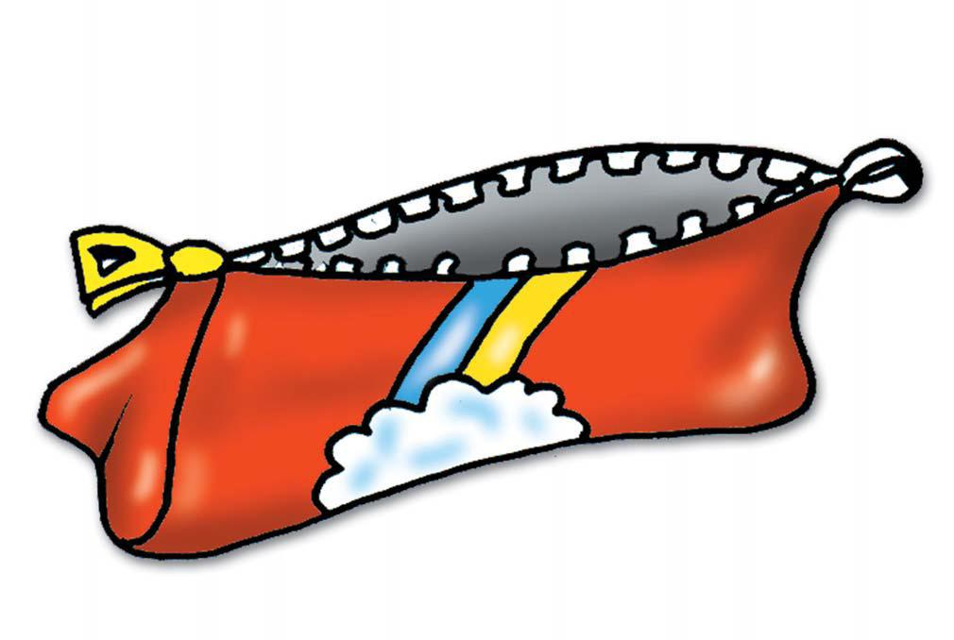

**book**

**pencil case**

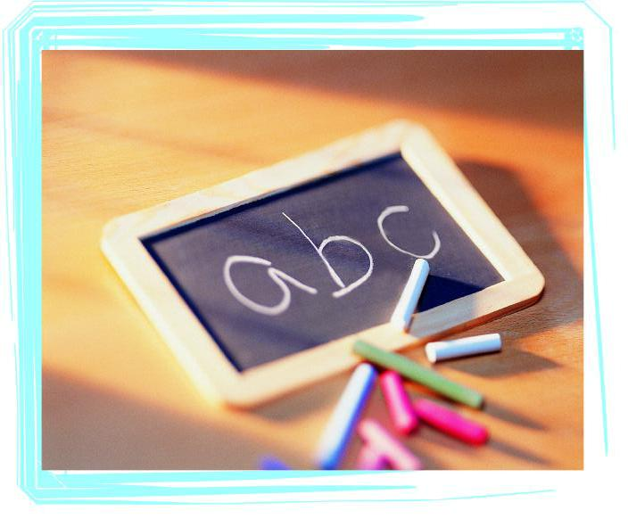

**_ _ _ _ _ _ _ _ _ _ _ _ _ _ _ _ _ _ _ _ _** **_ _ _ _ _ _ _ _ _ _ _ _ _ _ _ _ _ _ _ _ _** **_**

**English**

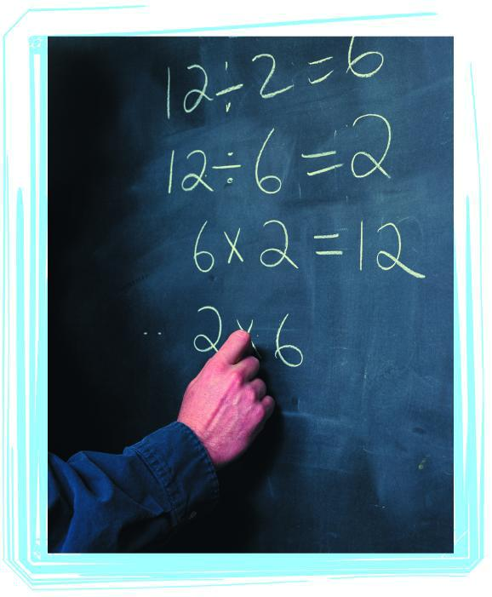

**_ _ _ _ _ _ _ _ _ _ _ _ _ _ _ _ _ _ _ _ _** **_ _ _ _ _ _ _ _ _ _ _ _ _ _ _ _ _ _ _ _ _** **_**

**Maths**

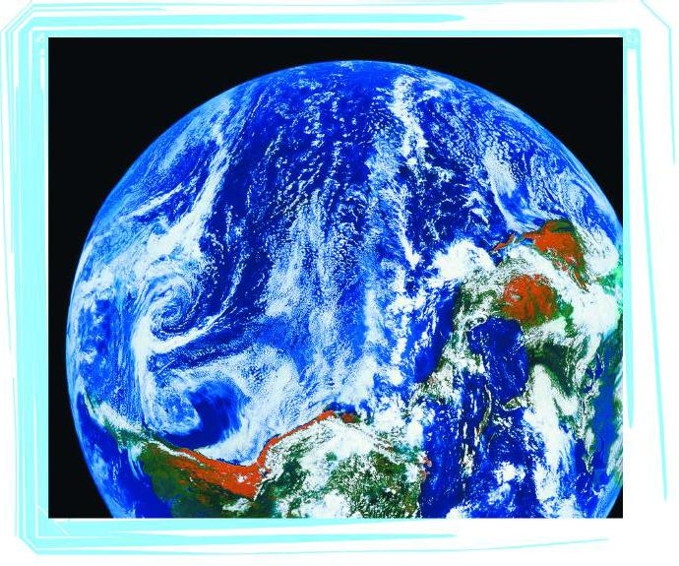

**_**

**_ _ _ _ _ _ _ _ _ _ _ _ _ _ _ _ _ _ _ _** **_ _ _ _ _ _ _ _ _ _ _ _ _ _ _ _ _ _ _ _ _** **_**

**Geography**

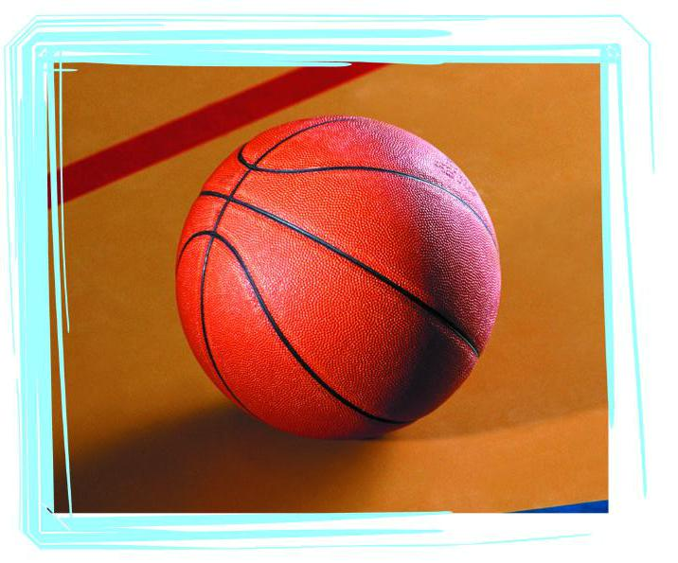

**_ _ _ _ _ _ _ _ _ _ _ _ _ _ _ _ _ _ _ _ _** **_ _ _ _ _ _ _ _ _ _ _ _ _ _ _ _ _ _ _ _ _** **_**

**PE**

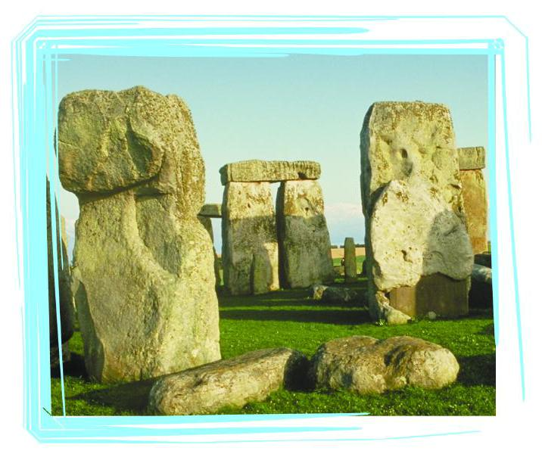

**_ _ _ _ _ _ _ _ _ _ _ _ _ _ _ _ _ _ _ _ _** **_ _ _ _ _ _ _ _ _ _ _ _ _ _ _ _ _ _ _ _ _** **_**

**History**

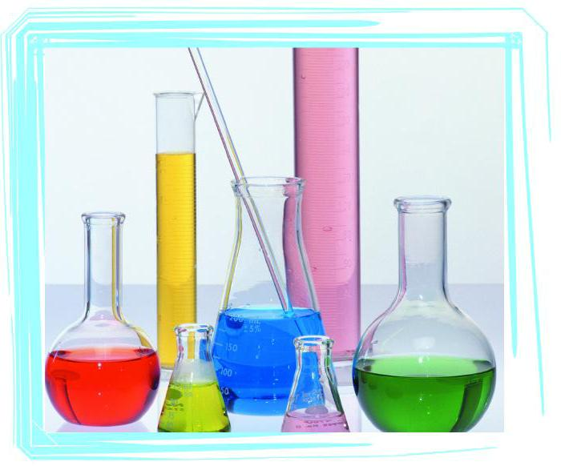

**_ _ _ _ _ _ _ _ _ _ _ _ _ _ _ _ _ _ _ _ _** **_ _ _ _ _ _ _ _ _ _ _ _ _ _ _ _ _ _ _ _ _** **_**

**Science**



**_ _ _ _ _ _ _ _ _ _ _ _ _ _ _ _ _ _ _ _ _** **_ _ _ _ _ _ _ _ _ _ _ _ _ _ _ _ _ _ _ _ _** **_**

**Art**

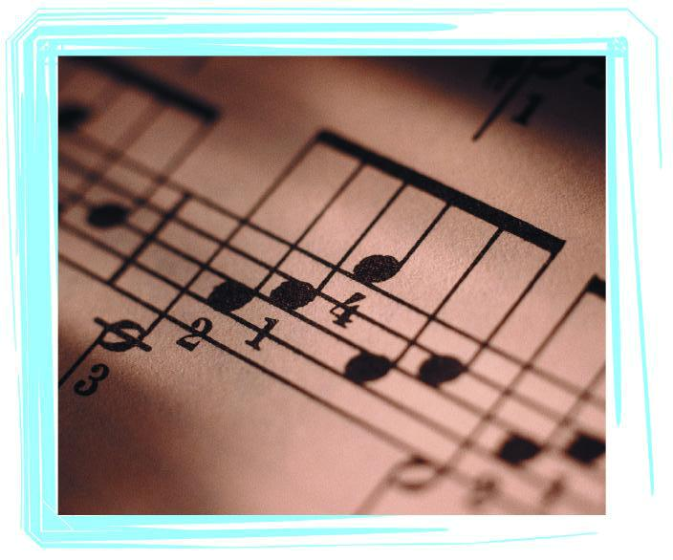

**_ _ _ _ _ _ _ _ _ _ _ _ _ _ _ _ _ _ _ _ _** **_ _ _ _ _ _ _ _ _ _ _ _ _ _ _ _ _ _ _ _ _** **_**

**Music**