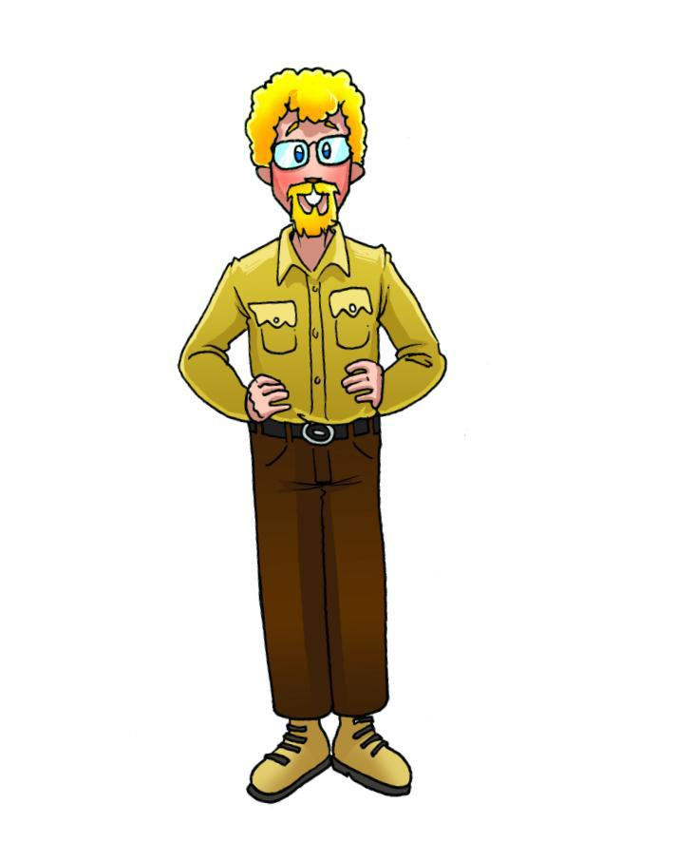

**_ _ _ _ _ _ _ _ _ _ _ _ _ _ _ _ _ _ _ _** **_ _ _ _ _ _ _ _ _ _ _ _ _ _ _ _ _ _ _ _ _ _** **_**



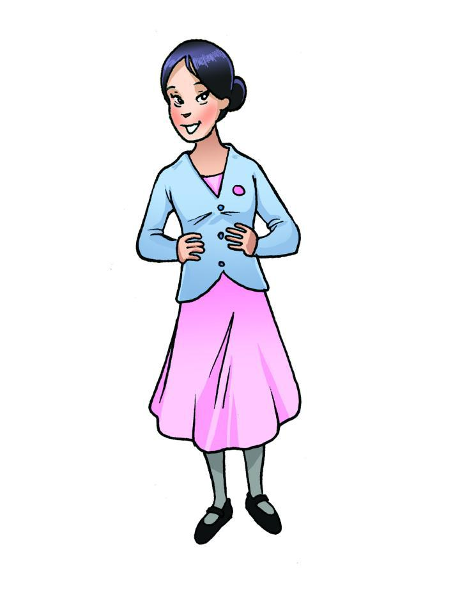

**_ _ _ _ _ _ _ _ _ _ _ _ _ _ _ _ _ _ _ _** **_ _ _ _ _ _ _ _ _ _ _ _ _ _ _ _ _ _ _ _ _ _** **_**



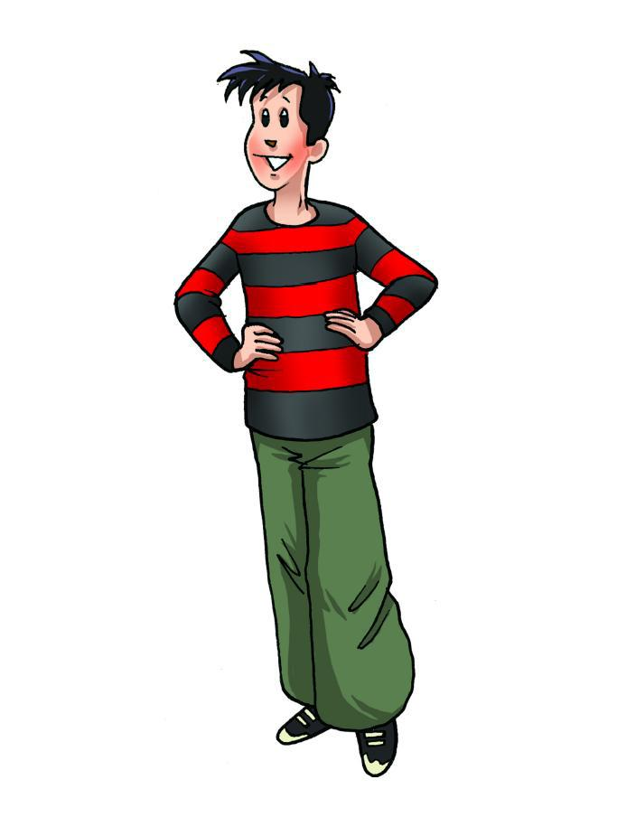

**_ _ _ _ _ _ _ _ _ _ _ _ _ _ _ _ _ _ _ _** **_ _ _ _ _ _ _ _ _ _ _ _ _ _ _ _ _ _ _ _ _ _** **_**



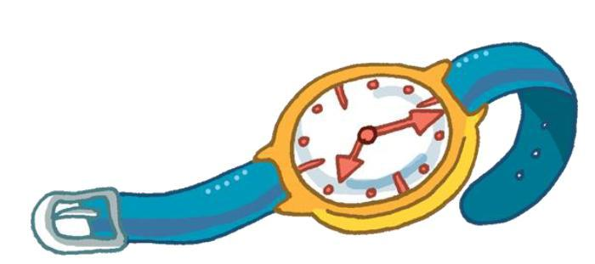

**_ _ _ _ _ _ _ _ _ _ _ _ _ _ _ _ _ _ _ _** **_ _ _ _ _ _ _ _ _ _ _ _ _ _ _ _ _ _ _ _ _ _** **_**



**watch**

**CDs**

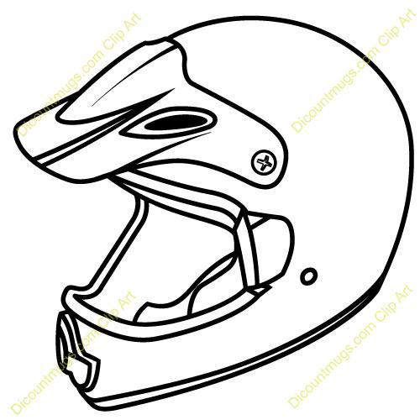

**_ _ _ _ _ _ _ _ _ _ _ _ _ _ _ _ _ _ _ _** **_ _ _ _ _ _ _ _ _ _ _ _ _ _ _ _ _ _ _ _ _ _** **_**

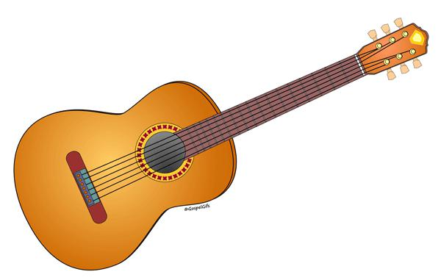

**helmet**

**guitar**

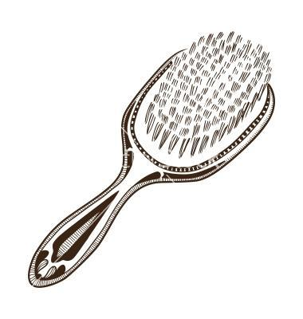

**_ _ _ _ _ _ _ _ _ _ _ _ _ _ _ _ _ _ _ _** **_ _ _ _ _ _ _ _ _ _ _ _ _ _ _ _ _ _ _ _ _ _** **_**



**hairbrush**

**camera**

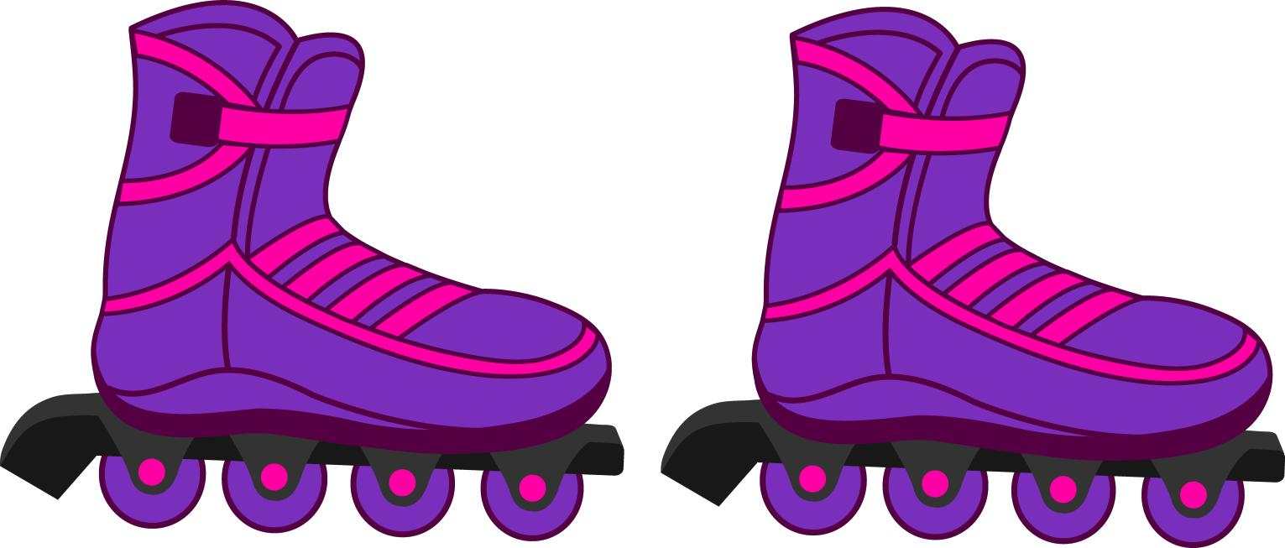

**_ _ _ _ _ _ _ _ _ _ _ _ _ _ _ _ _ _ _ _** **_ _ _ _ _ _ _ _ _ _ _ _ _ _ _ _ _ _ _ _ _ _** **_**

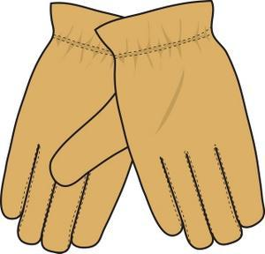

**roller blades**

**gloves**

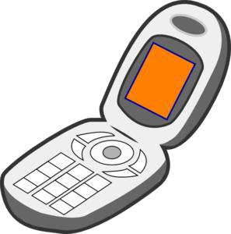

**_ _ _ _ _ _ _ _ _ _ _ _ _ _ _ _ _ _ _ _** **_ _ _ _ _ _ _ _ _ _ _ _ _ _ _ _ _ _ _ _ _ _** **_**

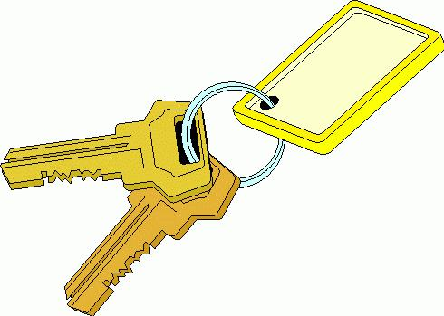

**mobile phone**

**keys**



                                          

